Troubleshooting Steps for Adobe eBook Technical Problems:
Deauthorizing & Reinstalling Adobe Digital Editions
to Resolve Authorization Errors

Instructions: Please follow the instructions in all 8 Steps below carefully -- and in the exact order they are listed. These steps will explain how to deauthorize, uninstall, reinstall, and reauthorize Adobe Digital Editions. The instructions will also review the steps required to transfer your Schema eBook to Adobe Digital Editions, using your Personal File Link.

Step I. Deauthorize the version of Adobe Digital Editions (ADE) software that you already have installed.
(Please note that the screen photos below may not be identical to the ones for your version of ADE.)
- Open ADE. Be sure that you are in the Library section of ADE, where you will find an icon or listing with each eBook you’ve installed – not the Reading section, where you view and print an eBook.
- Press Ctrl + Shift + D simultaneously on your keyboard. (If you have a Mac, press COMMAND + Shift + D.)
- In the pop-up window that opens, be sure that the email address you see is the same one that you used to obtain your Adobe ID originally. (See photo below.) Then enter the password for your Adobe ID account in the correct box. Click Continue.
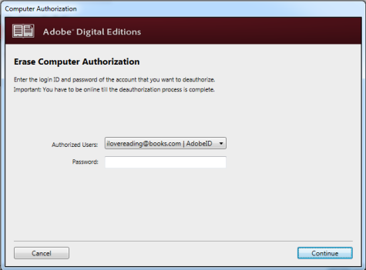

- A new window will open (see below). Click Erase Authorization.
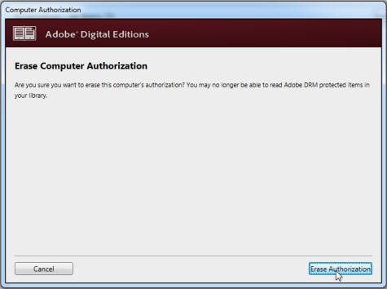
5. When the authorization has been erased, click OK to close the dialog box (see photo below). You will then see the main ADE screen.
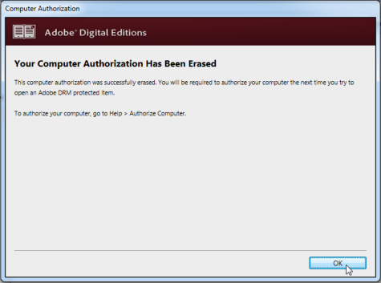

Step II. Close ADE. Then Uninstall ADE completely, using the standard procedure for removing software programs/apps with your computer.
Step III. Reboot your computer!
Step IV. Download, then begin installing, the latest version of ADE that is compatible with your computer’s Operating System. (You may be reinstalling the same version you originally had.)
1. Download the latest version of ADE that is compatible with your computer’s Operating System. To do this, first open the original email you received from us after placing your online order.
2. Click on the link named “View Purchase Online ”.
3. Click on the blue Download button next to the version of ADE you want to install.
If you’ve lost your confirmation email, you can also download ADE from the Adobe website instead:
http://www.adobe.com/solutions/ebook/digital-editions/download.html
4. Follow the rest of the instructions from our website to finish installing ADE, until you reach the step instructing you to obtain an Adobe ID:
For Windows: http://www.schematherapy.org/#!windows-ebook-installation/c1ma5
For Mac: http://www.schematherapy.org/#!mac-ebook-install/cv23
Step V. Authorize your new installation of ADE – as you originally did – using the same Adobe ID.
5. When you reach the step instructing you to sign up for an Adobe ID, instead use the same Adobe ID as you did originally (unless you believe that it was a faulty ID).
6. The Computer Authorization dialogue box usually opens automatically. If it does, skip to Step 7. If it doesn’t, follow the instructions in Steps 6a and 6b below.
a. If the Computer Authorization box does not open automatically, click on the Help menu near the top of the ADE Library screen.
b. Then click on "Authorize Computer...". The Computer Authorization dialog box will now open. (See photo below.)
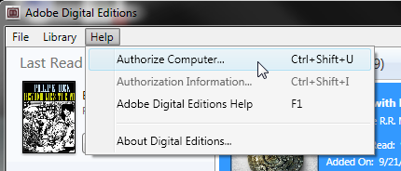

7. a. You will now Authorize Your Computer. In the field labeled “eBook Vendor”, be sure that “Adobe ID” is already selected. (See photo below.)
b. In the next two boxes, enter the same Adobe ID (email address) and Password that you signed up with originally. (Do NOT check the box that says: “I want to authorize my computer without an ID.”)
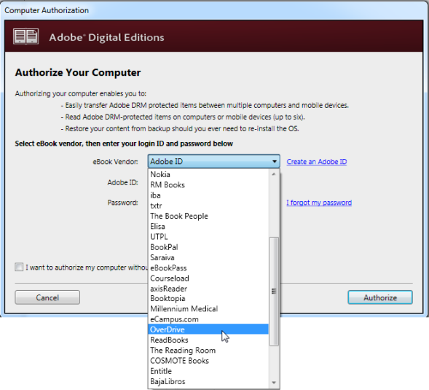
8. Click the “Authorize” button. ADE is now re-authorized with your Adobe ID on this computer.
Step VI. Close ADE. Then reboot your computer.

Step VII. Transfer your Schema eBook into ADE.
9. Depending on your issue, we MAY have sent you a separate email containing a Personal File Link to install the Adobe Compatibility Test eBook. If so, you will be notified of this in the accompanying email. (If not, skip to Instruction 10 below.)
a. If you were sent a link for the Compatibility Test eBook, please use this link for all of the instructions from 10 – 14 below first (before trying to reinstall the Personal File link you received with your original order).
b. If you are able to read and print all of the pages in the Compatibility eBook successfully, then return to Step 10 below, and follow the same instructions using the Personal File Link from your original purchase.
c. If the Compatibility Test eBook does not open in ADE, or if you cannot print all 6 pages, follow the instructions in the attached email instead of trying to install your original Personal File Link.
10. Open the confirmation email we sent you, containing the Personal File Link for your eBook (near the bottom of the email). Click on the file link. (If you prefer, you can also copy and paste the file link into the address bar of your browser; then hit the Enter key.)
11. After clicking on the Personal File Link, ONE of the following should happen (depending on your default browser and system configuration):
a. A window may open showing the eBook automatically being transferred into ADE. (If this happens, skip to Step 12.)
b. A window may open, offering you the option of opening the ***.acsm file in Adobe Digital Editions, or saving the file. If you see this window, select the Open option, then click “OK”, instead of saving the file. Then you should see a new window open, showing your eBook being transferred to ADE. If this happens, skip to Step 12.
If the only option offered is to SAVE the .acsm file, click “OK”; then skip to Step 11d below.
c. If you are not offered any options, then the .acsm file has probably been saved to your computer automatically. Skip to Step 11d. below.

d. Locate the .acsm file on your computer, then click on it. (You can usually find the file in your “Downloads” folder -- or in the Download bar or menu of your default browser.)
You should see a new window open, showing the eBook being transferred to ADE. (If this happens, continue to Step 12.)

Step VIII. Read and print your eBook from ADE.
12. The contents of your eBook should now open in ADE so that you can read all the pages. To view the pages, scroll up and down; you can also zoom to make the fonts larger or smaller.
13. To print from your eBook, click on the File menu, then click Print. Select the page numbers you want to print from the eBook, then click the Print button. The pages you selected should now print correctly.
Depending on your printer, you may find that the printed version looks slightly different from the on-screen view; for example, the margins may be different, or the font sizes may change. These can sometimes be adjusted by finding the printer properties page for your printer, and changing the scaling percentage.

14. If you still cannot read and print the pages from your eBook, please follow the instructions in the accompanying email.

(15. If you have completed these steps successfully using the Compatibility Test eBook, please follow all of the instructions from 10 to 14 above again, using the Personal File Link from your original purchase confirmation email.)

This is the end of the instructions.

Revised March 11, 2016

